DeepCSAT: E-Commerce Customer Satisfaction Prediction System

- Introduction
Customer Satisfaction (CSAT) is one of the most important metrics used by e-commerce companies to evaluate the quality of their customer support. When customers contact support teams regarding issues such as delayed delivery, refund problems, payment failures, or product defects, the quality and speed of the response strongly influence their satisfaction level.
This project, DeepCSAT, focuses on predicting the Customer Satisfaction Score (CSAT) using machine learning techniques. The system analyzes both structured information (such as response time, support channel, agent shift, and issue category) and unstructured text data (customer remarks) to predict whether the customer satisfaction will be high or low.
The goal of this project is to help customer support teams:
- Identify factors that affect customer satisfaction
- Predict satisfaction scores in advance
- Improve support response strategies
The final system includes:
- Data preprocessing and cleaning
- Exploratory Data Analysis (EDA)
- Feature engineering
- Machine learning model training
- Model evaluation
- A Streamlit web application for prediction

- Problem Statement
Customer support teams receive thousands of support tickets daily. It is difficult to manually analyze each interaction and understand whether the customer will be satisfied with the service provided.
Therefore, the objective of this project is:
To build a machine learning system that predicts the Customer Satisfaction Score (CSAT) based on customer interaction data.
This prediction can help companies:
- Detect potentially dissatisfied customers
- Improve response strategies
- Train agents more effectively

- Dataset Description

The dataset used in this project contains customer support interaction data from an e-commerce platform.
The dataset includes both structured features and textual feedback.
Important Features in the Dataset

Feature | Description
CSAT Score | Customer satisfaction rating (1–5)
response_time_hrs | Time taken by agent to respond
channel_name | Communication channel (Phone, Chat, Email)
category | Issue category
Sub-category | Specific issue type
Agent Shift | Agent working shift
Tenure Bucket | Agent experience level
clean_remarks | Customer textual feedback

These features are used to analyze customer behavior and predict CSAT.

4. Data Preprocessing

Before performing analysis or building machine learning models, the dataset needs to be cleaned and prepared.
Steps performed in preprocessing
- Handling missing values
- Cleaning text remarks
- Converting categorical variables
- Feature creation
- Sentiment analysis
Text Cleaning
Customer remarks often contain unnecessary characters, punctuation, or inconsistent formatting.
Text preprocessing steps included:
- Converting text to lowercase
- Removing special characters
- Removing extra spaces
This helps the machine learning model understand the text more effectively.
Feature Engineering
Additional useful features were created from the existing data.
Examples include:
1. remarks_length
Length of the customer remark.
2. sentiment_score
Sentiment score calculated using TextBlob.
Sentiment values range from:
- -1 → negative sentiment
- 0 → neutral
- +1 → positive sentiment
3. response_time_hrs
Time taken to respond to the customer.
These features help the model understand customer satisfaction patterns.

- Exploratory Data Analysis (EDA)

Exploratory Data Analysis is performed to understand patterns, relationships, and trends in the dataset.
EDA helps answer questions such as:
- What factors affect customer satisfaction?
- Which support channels perform better?
- Does response time impact satisfaction?

5.1 CSAT Distribution
This visualization shows how customer satisfaction scores are distributed across the dataset.
Typically, CSAT scores range from 1 to 5.
From the analysis, it was observed that:
- Most customers rated CSAT = 5
- Very few customers gave low ratings
This indicates that the dataset is highly skewed toward positive feedback.

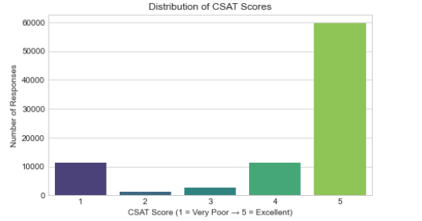
5.2 Response Time vs CSAT
This analysis examines the relationship between response time and customer satisfaction.
A visualization is created to compare average CSAT scores against response time.
Key observations:
- Faster responses generally lead to higher satisfaction
- Long response times often correspond to lower CSAT
This suggests that response time is an important factor affecting satisfaction.
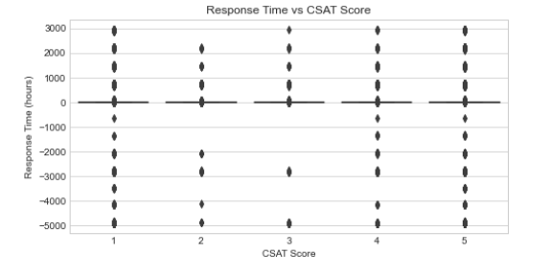
5.3 Hour and Weekend Patterns
Customer satisfaction may vary depending on the time of day or day of the week.
The analysis examines:
- Hourly trends
- Weekend vs weekday behavior
Key findings:
- Evening hours (6 PM – 10 PM) show slightly lower satisfaction
- Weekend support interactions also have lower CSAT scores
Possible reasons include:
- High ticket volume
- Limited staff availability
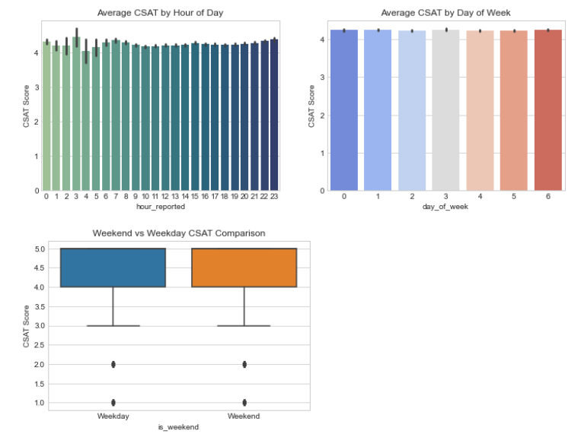
5.4 Agent and Shift Analysis
This analysis studies how agent shifts and experience levels impact customer satisfaction.
Features analyzed include:
- Agent Shift
- Tenure Bucket
Key findings:
- Experienced agents tend to receive higher CSAT scores
- Certain shifts show slightly lower satisfaction
This suggests that training and scheduling strategies may influence customer satisfaction.
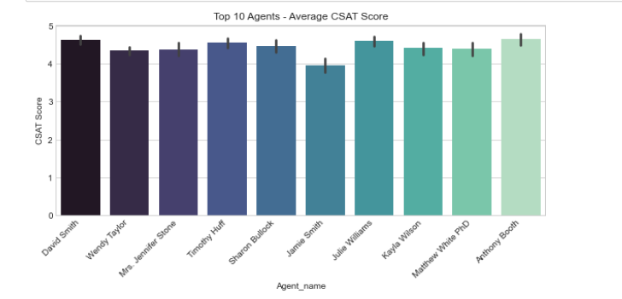
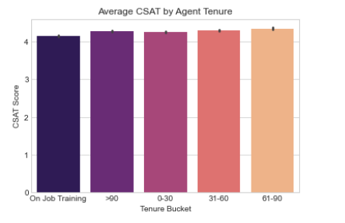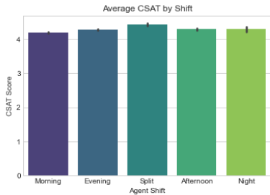

5.5 Remarks-Based Insights
Customer remarks provide valuable information about customer emotions and experiences.
Text analysis was performed to evaluate:
- Sentiment score
- Remark length
Findings include:
- Negative sentiment strongly correlates with low CSAT
- Positive remarks correspond to high satisfaction
Example:
Negative remark:
"Support was slow and the issue was not resolved"
Positive remark:
"Agent was very helpful and resolved my problem quickly"
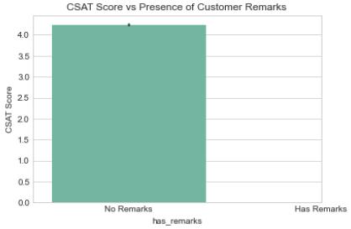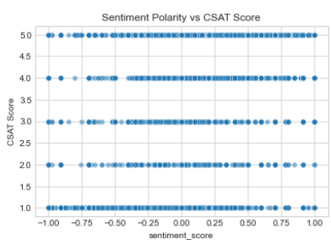
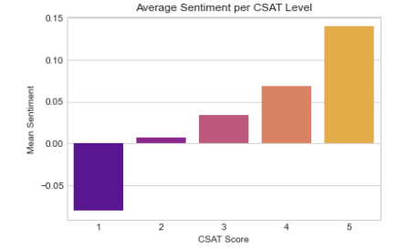

5.6 Category-wise CSAT Analysis
Different issue categories show different satisfaction levels.
Examples of categories:
- Delivery
- Payment
- Refund
- Product Quality
Key findings:
- Some categories consistently receive lower CSAT scores
- These categories require operational improvements
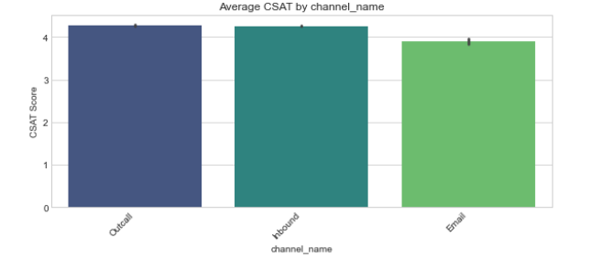
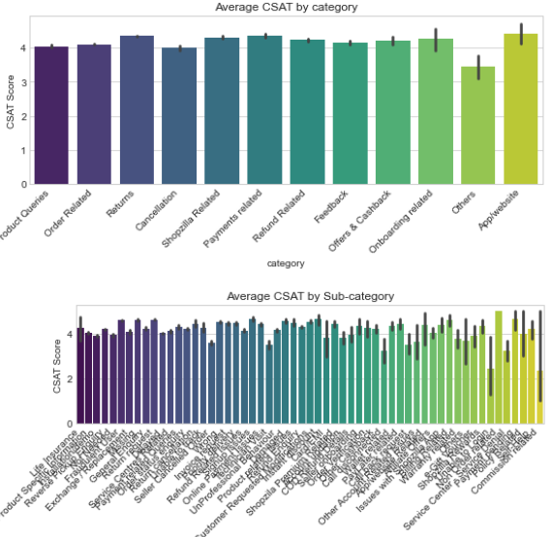

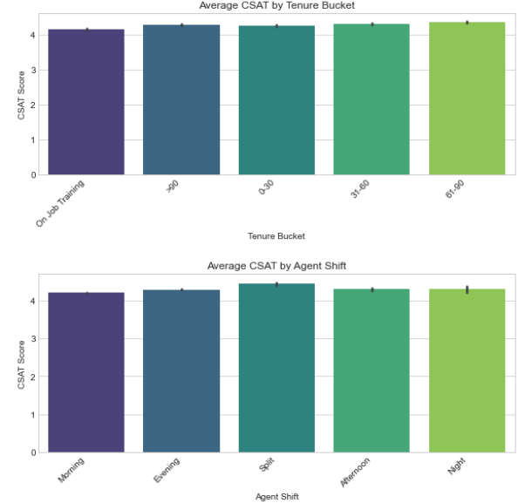
6. Machine Learning Models
After analyzing the dataset, machine learning models were trained to predict CSAT.
The following models were implemented:
- Logistic Regression
- Random Forest
- XGBoost
6.1 Logistic Regression
Logistic Regression is a statistical classification algorithm used for binary prediction.
In this project it predicts:
- High CSAT
- Low CSAT
Advantages:
- Simple
- Fast
- Interpretable
6.2 Random Forest
Random Forest is an ensemble learning method based on multiple decision trees.
Advantages:
- Handles complex relationships
- Reduces overfitting
- High accuracy
6.3 XGBoost
XGBoost is a powerful gradient boosting algorithm widely used in machine learning competitions.
Advantages:
- High predictive performance
- Handles large datasets
- Efficient training

7. Model Evaluation
Models were evaluated using standard classification metrics:
- Accuracy
- Precision
- Recall
- F1 Score
The model with the best performance was selected for deployment in the Streamlit application.

8. Model Deployment
After training the models, they were saved using Joblib so they can be loaded later by the web application.
Saved artifacts include:
- Trained ML models
- Label encoder
- Categorical feature values
These artifacts are used by the Streamlit application to make predictions.

9. Streamlit Web Application
A web application was built using Streamlit to demonstrate the CSAT prediction system.
The application allows users to:
- Enter customer remarks
- Provide ticket details
- Select issue category
- Predict customer satisfaction
9.1 Application Workflow
The workflow of the Streamlit app is as follows:
- User enters support ticket details
- Text remark is analyzed for sentiment
- Input data is prepared
- Machine learning model predicts CSAT
- Prediction result is displayed

10. Website Interface
The Streamlit website contains the following components:
Input Section
Users provide the following inputs:
- Customer remarks
- Agent shift
- Tenure bucket
- Communication channel
- Issue category
- Response time
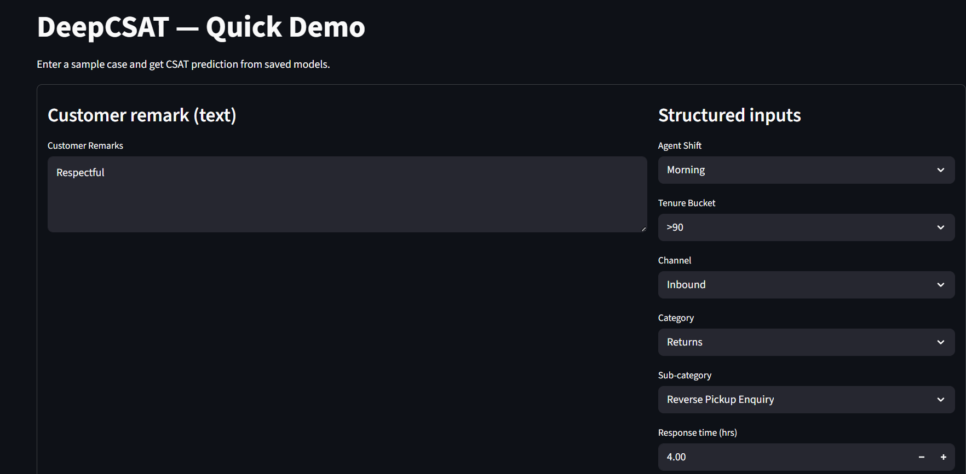Prediction Section
After clicking the Predict button, the model generates:
- Predicted CSAT label
- Prediction probability
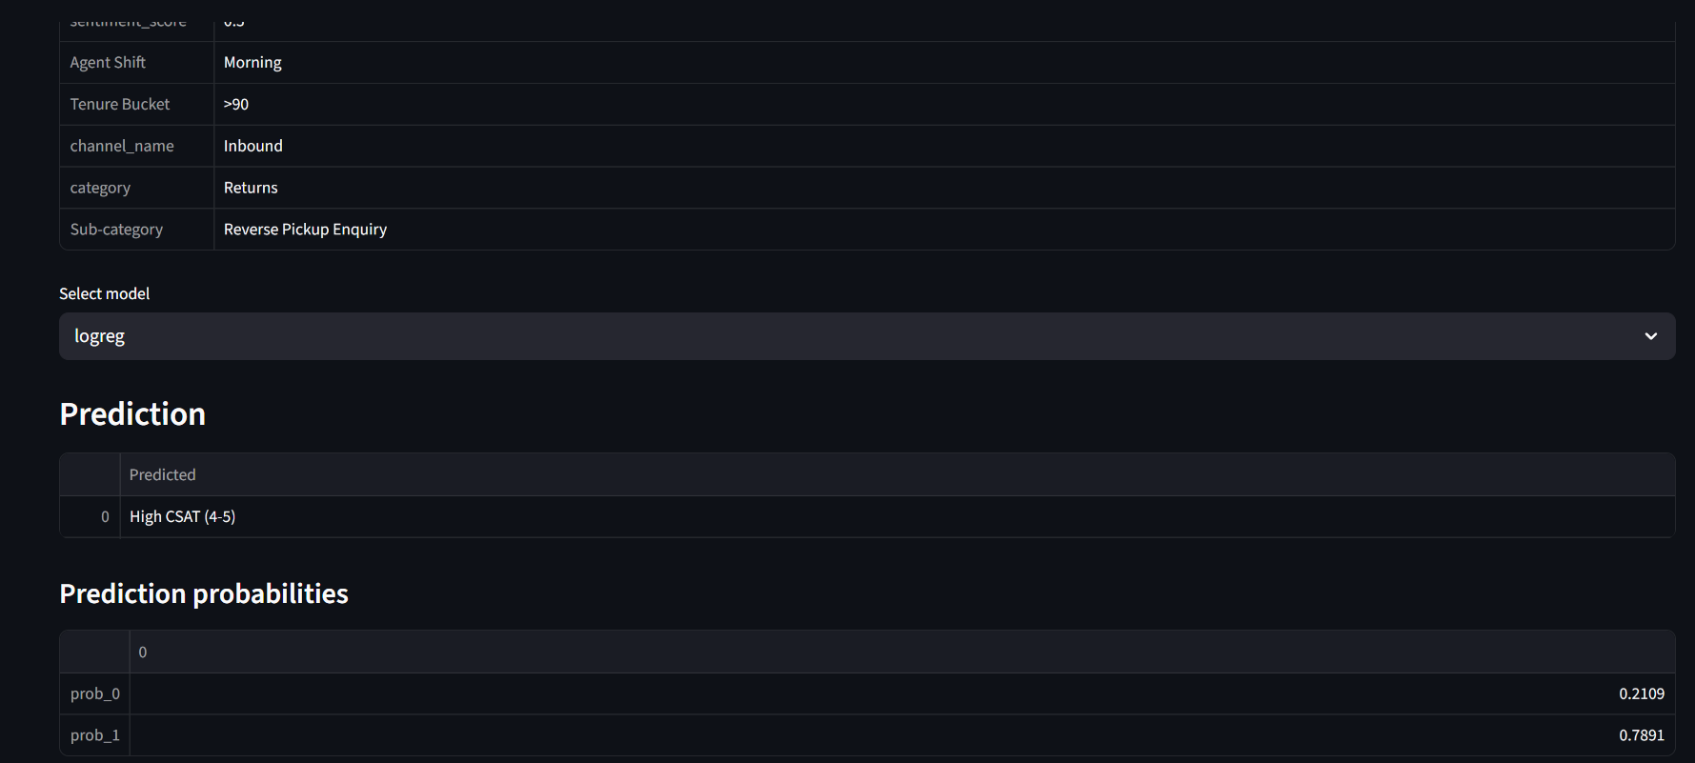Feature Importance
For tree-based models, the application also shows:
- Top features influencing the prediction

11. Project Architecture
The system architecture includes the following components:
- Data collection
- Data preprocessing
- Feature engineering
- Machine learning model training
- Model deployment
- Streamlit web application

12. Conclusion
The DeepCSAT project successfully demonstrates how machine learning can be used to predict customer satisfaction using both structured and unstructured data.
Key insights from the project include:
- Response time strongly affects satisfaction
- Sentiment of remarks indicates customer mood
- Agent experience improves service quality
The developed Streamlit application allows real-time CSAT prediction and can assist support teams in improving customer experience.

13. Future Improvements
The system can be improved further by:
- Using deep learning models for text analysis
- Integrating real-time customer support data
- Adding dashboard analytics for managers

14. References
- Python Documentation
- Streamlit Documentation
- Scikit-Learn Documentation
- XGBoost Documentation

